**Database**

**1.Creating Database:**

* Executed CREATE DATABASE diytools to create a new database for storing DIY project details.

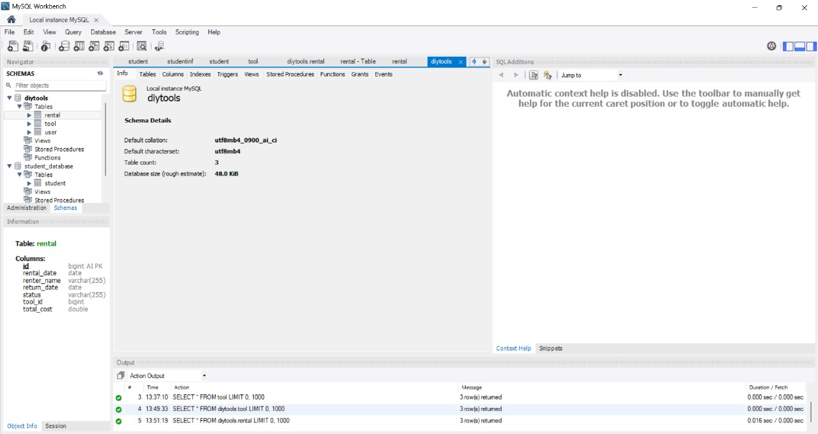

**Tables Creation:**

Table Creation for Tool in diytools Database

* Created a table named tool with fields: id, daily_rate, description, name, and status. Set id as Primary Key with Auto Increment option enabled.

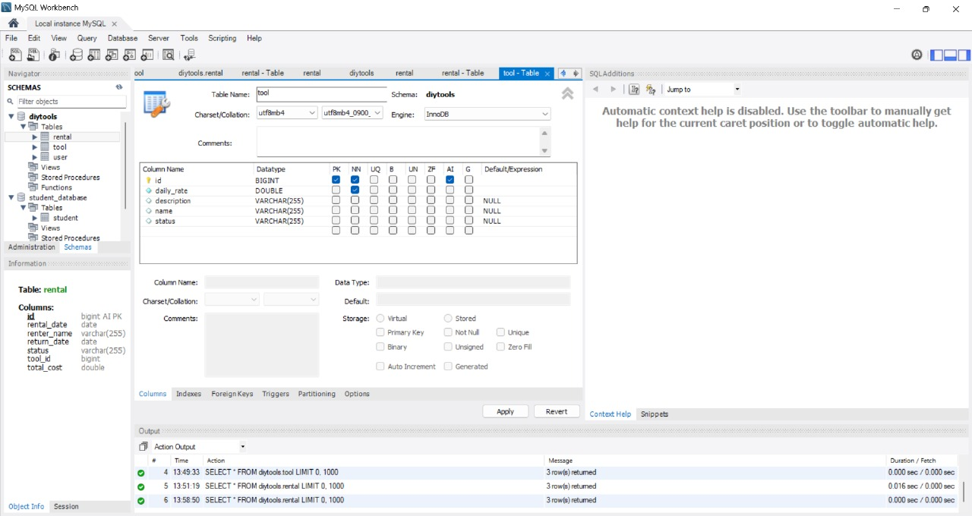

**Displaying Records from Tool Table:**

* Executed SELECT * FROM diytools.tool;
* To view all records from the tool table. Verified tool details like name, description, daily rate, and availability status.

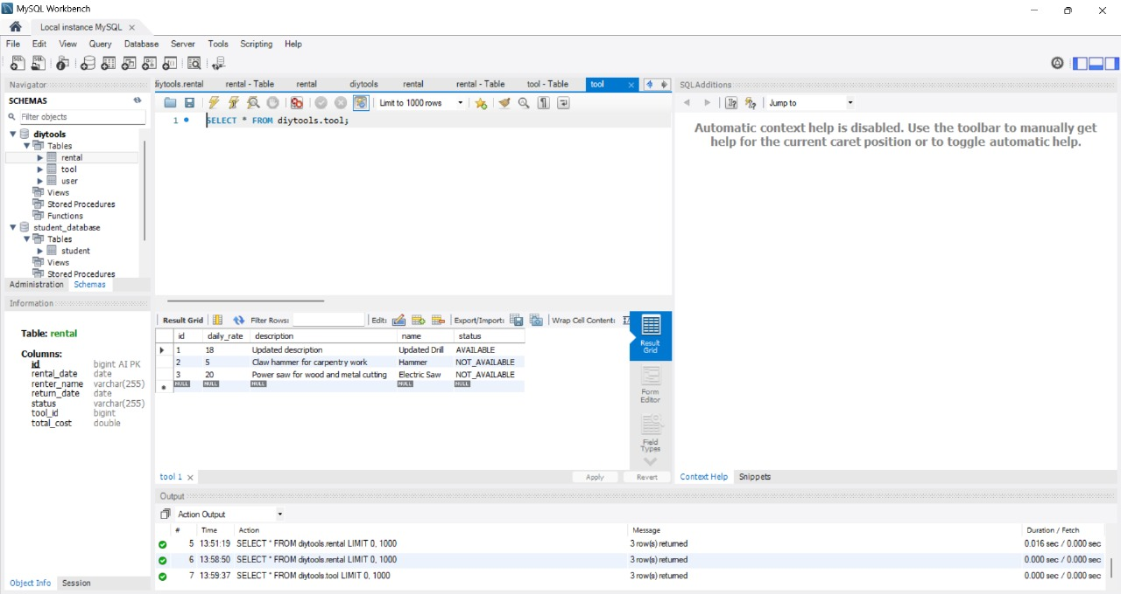

**Creating Rental Table in diytools Database:**

* Designed the rental table with fields for rental details including
* id, rental_date, renter_name, return_date, status, tool_id, and total_cost. Set id as the Primary Key with Auto Increment.

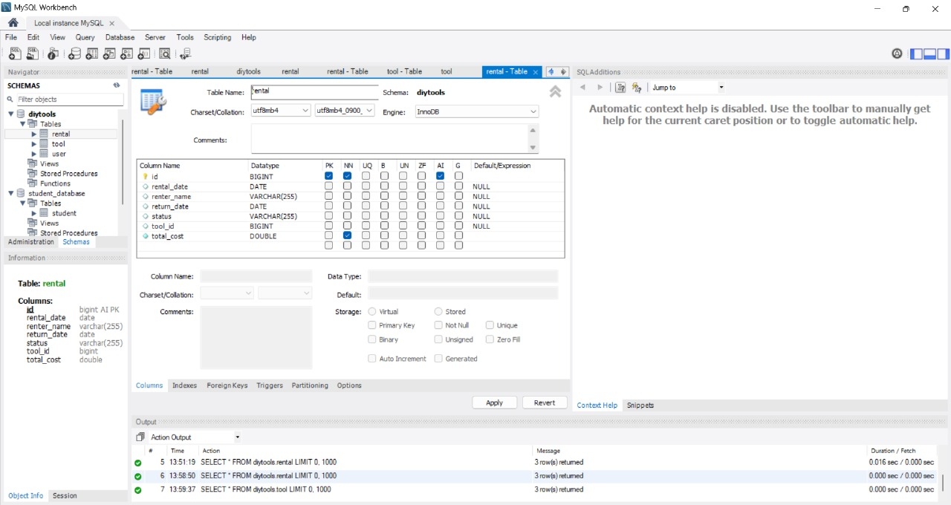

**Displaying Records from Rental Table:**

* Executed SELECT * FROM diytools.rental;
* To view all rental records. Verified rental details including renter name, rental dates, status, tool ID, and total cost.

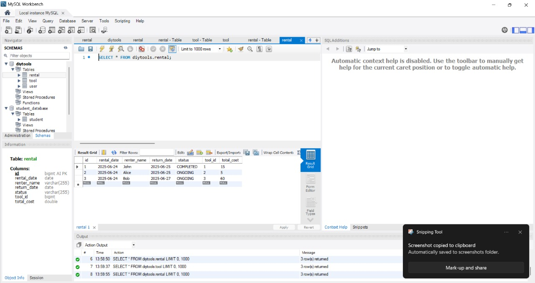

**Creating User Table in diytools Database**

* Created the user table with columns :
* id, password, and username. Set id as the Primary Key with Auto Increment enabled for unique user identification.

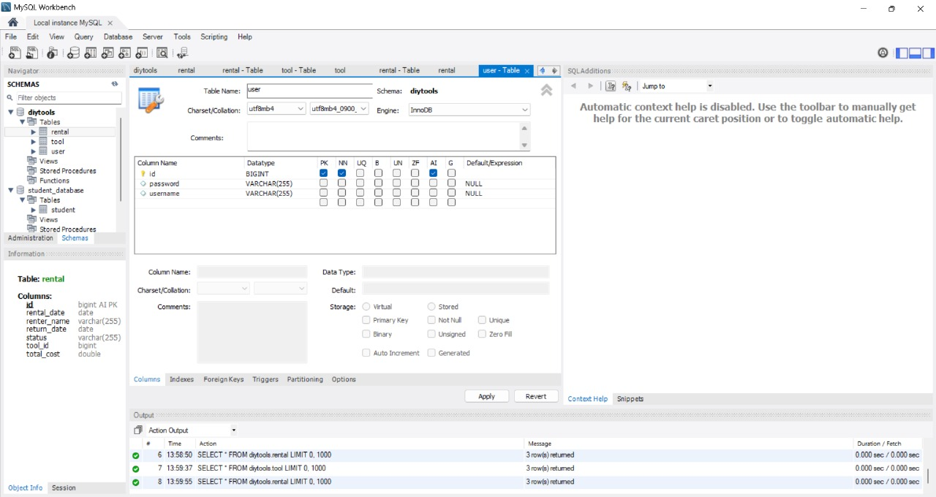

**Displaying Records from User Table:**

* Executed SELECT * FROM diytools.user;
* To view all user records. Verified user details including id, encrypted password, and username.

